PCI Industrial Card

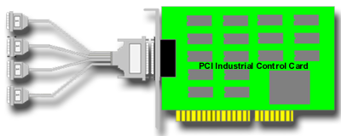

CHAPTER 1

INTRODUCTION

The PCI bus 4 channel industry control board is a 32 bits PCI bus board with Plug and Play (PnP) features, it is a programmable I/O interface card for PC/486, Pentium, or compatibles. The PnP features let hardware configuration for IRQ and I/O address is detected by BIOS automatically, you don’t need set switch and jumper.

The PCI bus 4 channel industry control board provides total 4 digital I/O ports, each I/O port contains 16 I/O lines, and can be set either input or output by the user's program. The signal assignments of PCI bus 4 channel industry control board is designed as a standard configurations, so that it can be used to connect to the expansion board for several applications, the expansion card family are 16/8 channel relay output board, 16/8 channel isolator input board, 8 channel SSR/Logic output board ... etc.

- The features of the PCI bus industry control board are:

- 32 bits PCI bus with Plug and Play (PnP) features.
- Provides four I/O ports.
- Each I/O port contains 16 digital I/O lines, total 64 I/O lines.
- Standard signal assignment to connect to expansion board family.
- Provides DII device driver for PnP features.
CHAPTER 2

UNPACKING INFORMATION

- Check that your PCI bus 4 channel industry control package includes the following items:

- PCI bus 4-channel industry control board.
- Demo Program.
- Data Capture Software Manual with Disk.
- DII device driver.
- User manual.
- Warranty form.
CHAPTER 3

HARDWARE INSTALLATION

Your PCI bus 4-channel industry control card is designed to be inserted in any available PCI slot in your PC/AT, PC/386, PC/486, Pentium or compatibles. In order to gain access to the expansion slots, follow the steps listed below:

- Turn off all power to your computer and all peripheral devices before installing your industry card.
- Remove the cover of the computer.
- Insert the industry control card into any available PCI slot. Make sure the adapter is firmly seated in the chosen slot.
- Replace the cover of the computer.
- Connects the expansion cable to 25 pin connectors.
- Turn on the power of your computer, the PnP features will recognize the industry control card.

CHAPTER 4

HARDWARE CONFIGURATION

The pin assignments of PCI bus 4-channel industry control card are:

- DB25 Pin Assignments for PORT 1

Pin | Function | Pin | Function
1 | + 12 V | 14 | GND
2 | +12 V | 15 | GND
3 | LINE 00 | 16 | LINE 01
4 | LINE 02 | 17 | LINE 03
5 | LINE 04 | 18 | LINE 05
6 | LINE 06 | 19 | LINE 07
7 | LINE 08 | 20 | LINE 09
8 | LINE 10 | 21 | LINE 11
9 | LINE 12 | 22 | LINE 13
10 | LINE 14 | 23 | LINE 15
11 | /CE 0 | 24 | /CE 0
12 | +5 V | 25 | GND
13 | -12 V

2. DB25 Pin Assignment for PORT 2

Pin | Function | Pin | Function
1 | + 12 V | 14 | GND
2 | +12 V | 15 | GND
3 | LINE 00 | 16 | LINE 01
4 | LINE 02 | 17 | LINE 03
5 | LINE 04 | 18 | LINE 05
6 | LINE 06 | 19 | LINE 07
7 | LINE 08 | 20 | LINE 09
8 | LINE 10 | 21 | LINE 11
9 | LINE 12 | 22 | LINE 13
10 | LINE 14 | 23 | LINE 15
11 | /CE 1 | 24 | /CE 1
12 | +5 V | 25 | GND
13 | -12 V
3. DB25 Pin Assignment for PORT 3

Pin | Function | Pin | Function
1 | + 12 V | 14 | GND
2 | +12 V | 15 | GND
3 | LINE 00 | 16 | LINE 01
4 | LINE 02 | 17 | LINE 03
5 | LINE 04 | 18 | LINE 05
6 | LINE 06 | 19 | LINE 07
7 | LINE 08 | 20 | LINE 09
8 | LINE 10 | 21 | LINE 11
9 | LINE 12 | 22 | LINE 13
10 | LINE 14 | 23 | LINE 15
11 | /CE 2 | 24 | /CE 2
12 | +5 V | 25 | GND
13 | -12 V
4. DB25 Pin Assignment for PORT 4

Pin | Function | Pin | Function
1 | + 12 V | 14 | GND
2 | +12 V | 15 | GND
3 | LINE 00 | 16 | LINE 01
4 | LINE 02 | 17 | LINE 03
5 | LINE 04 | 18 | LINE 05
6 | LINE 06 | 19 | LINE 07
7 | LINE 08 | 20 | LINE 09
8 | LINE 10 | 21 | LINE 11
9 | LINE 12 | 22 | LINE 13
10 | LINE 14 | 23 | LINE 15
11 | /CE 3 | 24 | /CE 3
12 | +5 V | 25 | GND
13 | -12 V

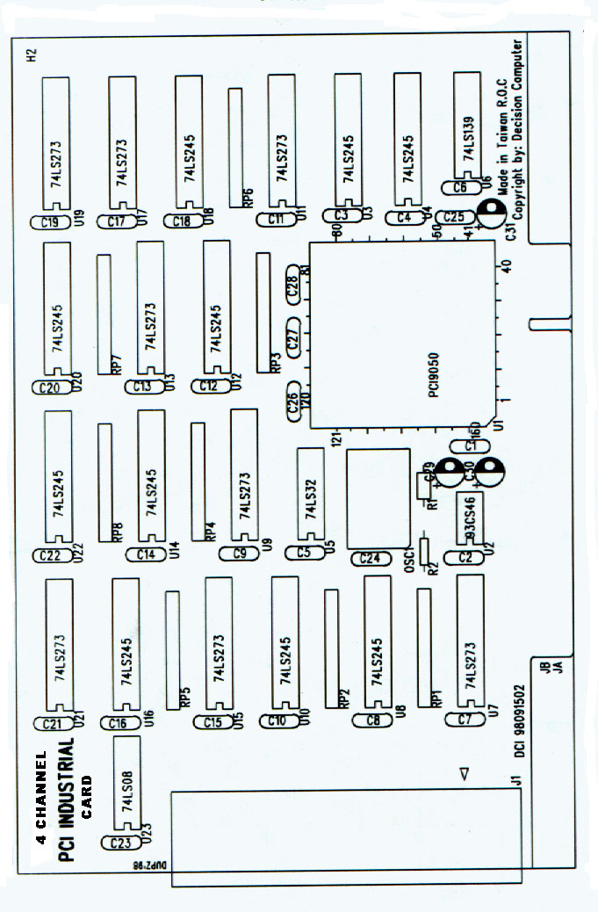
CHAPTER 5

DII DEVICE DRIVER

To install DII (Decision Industrial Interface) for Windows 95 and Windows NT, you may start the installation by running SETUP.EXE supplied on this distribution CD. During installation, the Setup application will install an icon into a new program group in your start menu (default name: "Decision Industrial Interface"). After DII is installed, please select “Start” menu, then “Settings”, then “Control Panel”, then “Add New Hardware” menu, then select PCI industrial control card on the “Industrial I/O Devices” hardware group.

The DII provides DLL, OCX, ... etc. components for further programming. For more details, please refer DII manual.

APPENDIX A

WARRANTY INFORMATION

A.1 Copyright

Copyright 1998, 1999 DECISION COMPUTER INTERNATIONAL CO., LTD. All rights reserved. No part of INDUSTRY CONTROL CARD software and manual may be reproduced, transmitted, transcribed, or translated into any language or computer language, in any form or by any means, electronic, mechanical, magnetic, optical, chemical, manual, or otherwise, without the prior written permission of DECISION COMPUTER INTERNATIONAL CO., LTD.

Each piece of INDUSTRY CONTROL CARD package permits user to use INDUSTRY CONTROL CARD only on a single computer, a registered user may use the program on a different computer, but may not use the program on more than one computer at the same time.

Corporate licensing agreements allow duplication and distribution of specific number of copies within the licensed institution. Duplication of multiple copies is not allowed except through execution of a licensing agreement. Welcome call for details.

A.2 Warranty Information

DECISION warrants that for a period of one year from the date of purchase (unless otherwise specified in the warranty card) that the goods supplied will perform according to the specifications defined in the user manual. Furthermore that the INDUSTRY CONTROL CARD product will be supplied free from defects in materials and workmanship and be fully functional under normal usage.

In the event of the failure of a INDUSTRY CONTROL CARD product within the specified warranty period, DECISION will, at its option, replace or repair the item at no additional charge. This limited warranty does not cover damage resulting from incorrect use, electrical interference, accident, or modification of the product.

All goods returned for warranty repair must have the serial number intact. Goods without serial numbers attached will not be covered by the warranty.

Transportation costs for goods returned must be paid by the purchaser. Repaired goods will be dispatched at the expense of INDUSTRY CONTROL CARD.

To ensure that your INDUSTRY CONTROL CARD product is covered by the warranty provisions, it is necessary that you return the Warranty card.

Under this Limited Warranty, DECISION's obligations will be limited to repair or replacement only, of goods found to be defective as specified above during the warranty period. DECISION is not liable to the purchaser for any damages or losses of any kind, through the use of, or inability to use, the INDUSTRY CONTROL CARD product.

DECISION reserves the right to determine what constitutes warranty repair or replacement.

Return Authorization: It is necessary that any returned goods are clearly marked with an RA number that has been issued by DECISION. Goods returned without this authorization will not be attended to.

